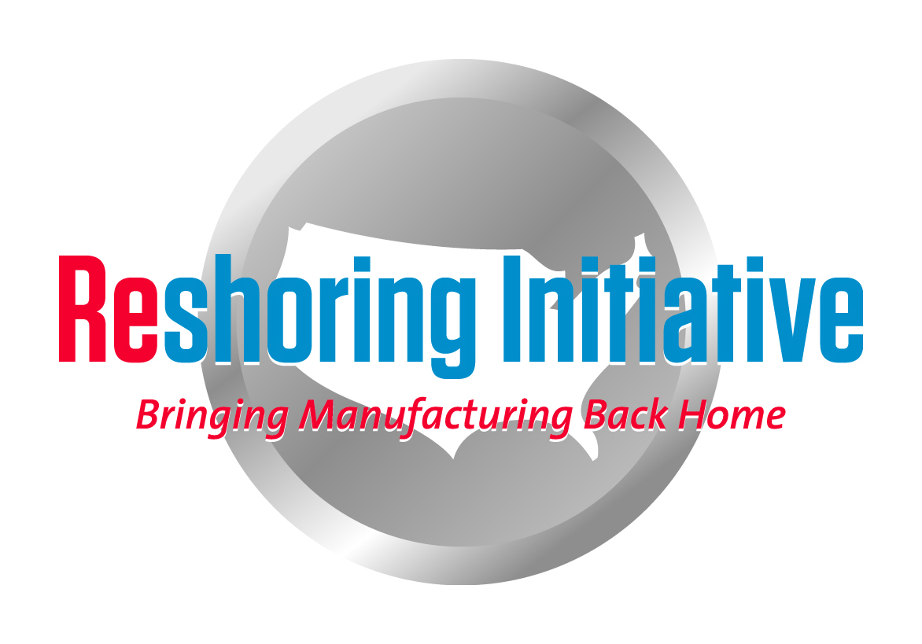
Economic Development Program Proposals

The Reshoring Initiative recommends the high impact-minimal cost economic development programs outlined below and is seeking regions interested in developing these opportunities

- Organized Reshoring Program:
Substitute local production for products and components currently imported to the region from offshore. A package is available from the Reshoring Initiative and Datamyne to help EDOs bring back offshored work:
- Description:
- Use the Datamyne database to identify all imports by regional companies, generally OEMs.
- Decide which imports are, in aggregate, in large volume and could be replaced by regional existing capacity: in-house or SMEs.
- Ask the importers to consider producing or sourcing locally. The importers will say they do not source locally because prices are much lower (typically 30%) offshore.
- Educate the involved importers with the Reshoring Initiative’s free Total Cost of Ownership (TCO) Estimator to reevaluate offshoring vs. reshoring, e.g. to see that there is often no or only a small TCO difference with local sourcing.
- Bring importers and suppliers together in a Purchasing Fair to start the shift of work from offshore. Our user data suggests that about 25% of offshored work would come back if TCO is consistently used.
- Identify at the companies any remaining TCO gaps vs. offshore. To close remaining small gaps, utilize a team, as needed:
- Automation: machine tool and automation distributors and producers
- Workforce technology skills training: technology providers and distributors, trade associations, community colleges
- Lean and other process improvements: MEP (Manufacturing Extension Partnership), AME (Association for Manufacturing Excellence), etc.
- Economic Development assistance: EDOs
- Using the TCO software, forecast when additional work will be reshorable and follow-up accordingly
- Benefits:
  - Work comes back from offshore rather than neighboring states. Much more win/win.
  - Minimal incentives, since the work comes back in the self-interest of the involved companies!
  - Strengthens local ecosystems around OEMs to make them more successful and more firmly linked to the region.
  - Recruit other U.S. companies or FDI to fill large supply gaps.
  - Feeds the skilled workforce program listed below.
- Skilled workforce:
The bottleneck to expanding the skilled workforce is recruitment: few students want to follow STEM fields, esp. manufacturing. The following programs are crafted to overcome at minimal cost 2 key issues in recruitment:
1. Perception of ongoing manufacturing decline: Belief that there is no future in manufacturing, that all the work will go offshore
a. Promote the success of reshoring to improve the attractiveness of manufacturing careers.
b. Organize NAM (National Association of Manufacturing) and local groups like NTMA, EDOs, MEPs, AME and the community colleges to gather local reshoring cases. Publish locally as “The regional Reshoring Cases of the Month.” and submit nationally. Reshoring Initiative has an online case reporting capability in place.
c. Reshoring needs recruiting. Recruiting needs reshoring to be visibly succeeding.
d. Benefit: Motivates students to select, guidance counselors to recommend and schools to provide skills training.

2. Perception of low prestige and income: Belief that vocations/trades training is lower than a 4-year university degree which is the only route to middle income careers.
a. Terminate the use of “Vocation” and “trades.”
b. Refer to the skilled occupations as professions and the workers as professionals as is done in Germany and Switzerland.
c. Requires the cooperation of K-12 educational system, community colleges, media, employers, EDOs, etc.
d. As manufacturing skilled workers take on more mental and less physical responsibilities, the “professional” terminology is increasingly appropriate.
e. Benefit: Increases attractiveness of skills training and careers
3. Document that training pays: Include in BLS data, incomes of workers who have passed apprenticeships or have a strong portfolio of credentials. I presented this idea to DOL on 9/18/12. Based on our discussion, BLS has added at the bottom of a key page that shows the relationship between income and degree level a note re apprenticeships and training and changed the heading from “Education Pays” to more neutral text. They have started a survey to collect the data. By making available to guidance counselors and school administrators data showing that there are “Other Ways to Win” we will attract higher caliber recruits. High impact-almost no cost.

In all programs, we would be delighted to help make your region the model for the rest of the country.

Harry C. Moser
Founder and President
Reshoring Initiative
Office +01 847 726 2975
Mobile +01 847 867 1144
email: harry.moser@reshorenow.org
web: http://www.reshorenow.org

