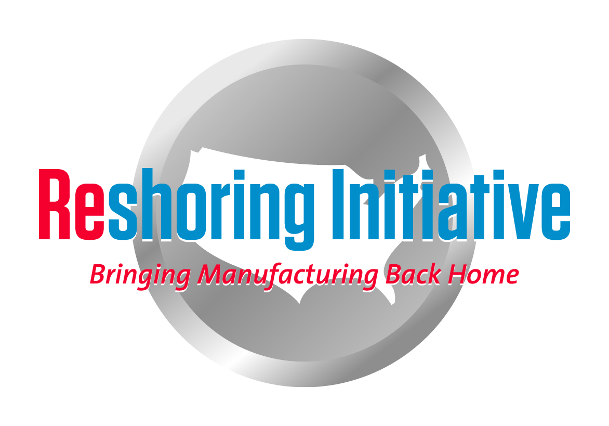
Tutorial: Getting your company or a customer started on TCO
- Getting companies’ attention:
- Ask about pain and opportunities
- Pain theory
- Delivery
- Orders lost due to delivery or response
- Quality
- Excess inventory
- Travel
- Late night calls
- IP loss or risk
- Regulatory issues
- Purchase price rising
- Corruption
- Violence
- Natural disasters or political instability
- Work with natural allies: Lean, Green, compliance, quality, line management. Work from your strengths and contacts in these areas.
- Ask how they decide on sourcing: PPV, Landed Cost or Total Cost of Ownership
- Appeal mainly to their bottom line.
- Which parts to analyze:
- Follow these general priorities for selecting parts to evaluate:
- Keep existing domestic sources: decide not to offshore
- Shift outsourcing back
- Repurpose offshore own-facility to serve the offshore market. Incrementally invest domestically to serve domestic market
- Shut offshore own facility. Build new domestic facility.
- Use the Library to check what their industry has done
- Families of parts

Develop a sales tool kit
- Use our Case Studies feature to collect Cases. Post on your website.
- Get publicity
- For help: email Harry. Can be available to convince customers by phone or live.
Harry Moser 2/4/14
Harry.Moser@ReshoreNow.org

