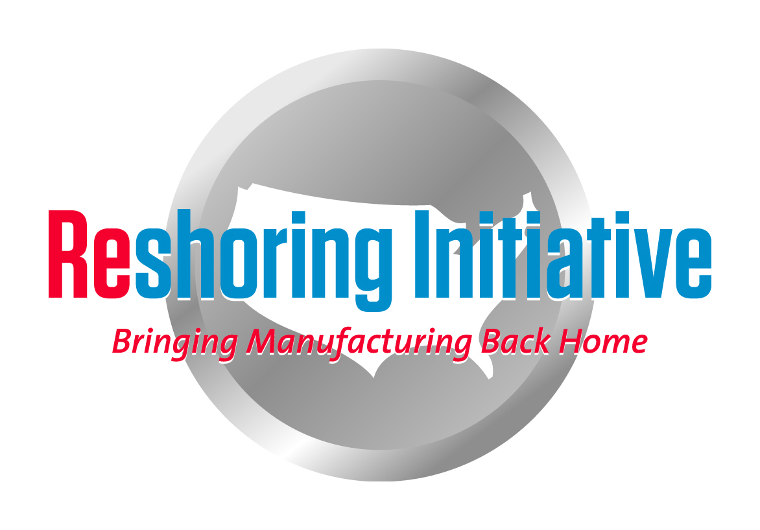
TCO Estimator Tutorial
- Using the TCO Estimator online
- Go to www.reshorenow.org
- Click on TCO Estimator
- Create a new account
- Fill in the blanks
- You will receive an email with instructions and the link to activate your account.
- Log on
- Click on View Example Form for a completed example. Be sure you click on Experimenting, Offshore, Outsourced, Outsourced at the top of the form if they are not already clicked.
- Click on Complete and View Results at the bottom of the page to see the TCO calculation.
- Go back to the blank Input Page by clicking on the other tab at the top.
- Answer the questions at the top of the form.
- Be sure to click on “Real Case” if you are analyzing a real case with best available data.
- Click on “Experimenting” is you are just checking-out the system
- You must answer the check box questions or you will not be able to see the Results page
- We promise to keep your data confidential. We analyze and publish aggregate data but never release any data on individual cases
- Input data and estimates. The TCO Estimator provides:
- Surface freight cost from offshore country’s port of exit to Chicago.
- Air freight from a major airport in the country to O’Hare.
- The calculation tool to calculate 29 costs based on your inputs.
- You can Save and come back. So just start and find out what additional values you need.
- Many of the factors are expressed as a % of the purchase price of the item being analyzed.
- For qualitative factors:
a. Do not expect perfection
b. Achieve relative accuracy: by part and country
c. Seek expert sources on the internet, e.g. Maplecroft on risk, Dept. of Commerce’s ACETool on a broad range if issues.
- Review the Explanations on the Inputs page and the formulas on the Results page to help you refine your inputs.
- When you have valued all possible factors, click on “Complete and View Results.”
- The Results page shows the calculated costs, the formulas and line graphs of the U.S. and offshore TCO and price, how cost accumulates for each source and a 5 year forecast of TCO for each source.
- Review costs on the Results page. If any are unreasonably high or low vs. other factors or vs. the other supplier, reevaluate your inputs.
- If you have questions or suggestions, you can email me at info@reshorenow.org.

- General plan for applying the TCO Estimator at a company
- Sort the relevant components by family of parts.
- Run a sample from each family thru the Estimator
- Develop rules for each family, e.g.: “offshore price must be X% lower”
- Note: Intended as:
- A good analytical tool for the $100,000 Buy decision
- A place to start and a great list of costs to consider for the $10M Buy decision or the $100M Make, new facility, decision.
- Other thoughts:
- Seek domestic improvement for cases where TCO is close.
- For in-house: remember burden will not automatically be eliminated when you offshore and will be absorbed when you reshore.

Harry Moser 1/20/14
Harry.Moser@ReshoreNow.org

